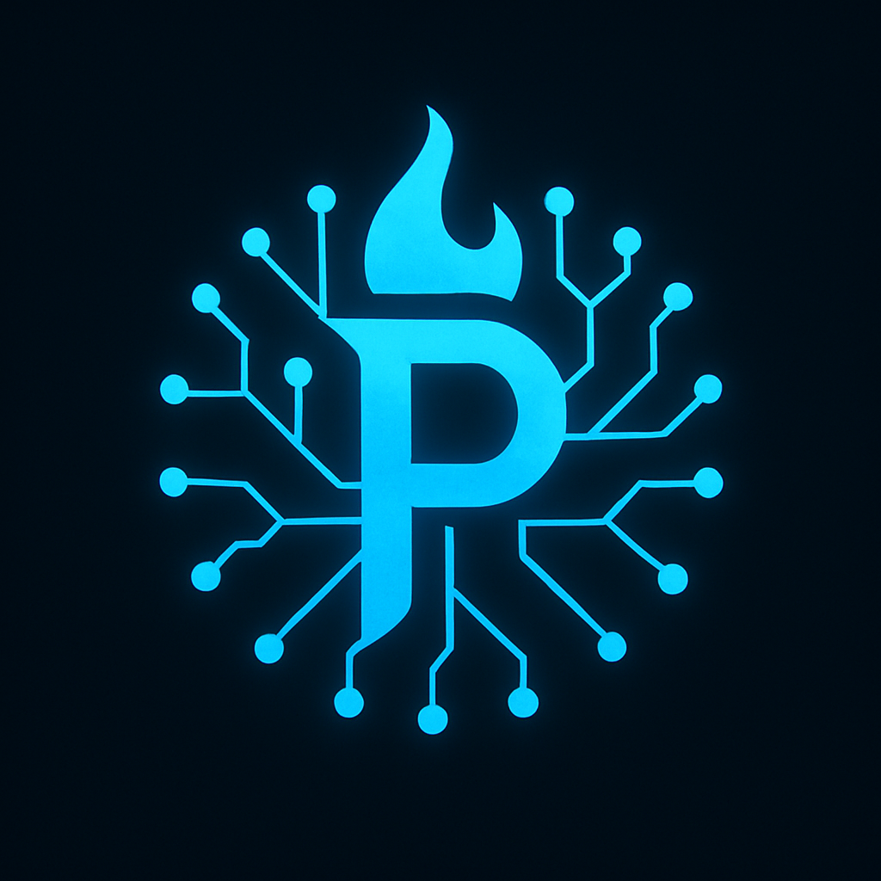

Welcome to Prometheus

Skill-Based Coaching & High-Performance Life Planning

Built to help you reclaim structure, sharpen your focus, and rebuild stronger than ever.

# What You Just Bought

You now have access to Prometheus—your personal AI strategist, goal architect, and no-BS planning assistant. This isn’t therapy. This isn’t fluff. It’s structure, clarity, and fire—on your terms.  
Inside this download, you’ll find:  
- Your private link to the Prometheus AI  
- A 3-day Quick-Start Setup Plan  
- Bonus tips to maximize your results

# Step 1: Access the AI

Click the link below to open Prometheus in ChatGPT (ChatGPT Plus required):  
[>> Access Prometheus Now](YOUR-LINK-HERE)  
(*If you haven’t already, sign into ChatGPT and activate the link.*)  
  
Make sure to bookmark the page—this is your permanent access.

# Step 2: Your 3-Day Quick Start Plan

## Day 1 – Get Grounded

Say:  
"Prometheus, help me define the 3 most important areas of my life right now."  
  
You’ll build focus. Choose one priority to improve first—health, finances, discipline, relationships, or purpose.

## Day 2 – Map the Fire

Say:  
"Prometheus, help me create a short-, mid-, and long-term plan for [my goal]."  
  
You’ll get a structured breakdown—daily habits, 30-day missions, and 12-month objectives.  
Write them down. Print them out. This is your new blueprint.

## Day 3 – Lock It In

Say:  
"Prometheus, create a weekly ritual and daily habits to keep me accountable and moving forward."  
  
You now have a system. Set a time each week to check in with Prometheus, update your goals, and reflect.

# Tips to Get the Most Out of Prometheus

- Be honest. Prometheus works best when you're real about what’s in your way.  
- Talk to it like a coach. Give context. Ask for specifics. Push back if needed.  
- Save your best outputs. Screenshot or copy what matters—you’ll refer back later.  
- Use it daily or weekly. Make it part of your rhythm—not just a one-time tool.

# Need Help? Feedback? Ideas?

This is just the beginning. If you have suggestions, hit a roadblock, or want to share a win—email me:  
[YOUR EMAIL HERE]  
Your feedback shapes future versions and updates.

# Final Note

You’re not alone. You’re not broken. And you’re not done.  
Prometheus was built by someone who knows the fire—and still walks through it.  
  
Now it’s your turn.

– Prometheus Support Team (a.k.a. just a guy named Bryan who built this damn thing to survive)